|  |  |
| --- | --- |
| **Physical Development** | |
| **Positional movements** | We learn to move in different ways. Using mathematical language we learn to move over, under, around and through objects. We can climb up and down and safely use stairs independently. |
| **Equipment** | We learn to name and recognise sporting equipment. We use different size and shaped equipment to help us understand how to take part in a variety of sports when we are older. We learn to throw and catch, kick and roll balls in small groups. |
| **Locomotion** | We learn how to move forward and backwards at different paces. We learn that we can move on our hands and feet. We learning to hop, skip and jump safely on and off apparatus. |
| **Dancing** | We learn to listen to music and move our bodies to a beat. We experiment with stamping our feet and clapping our hands. Using familiar topics we create small routines to share with friends. |

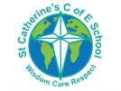

**Overview**

At St Catherine’s as a part of physical development we learn how to stay healthy and take part in a variety of sports and activities.

We learn the 3 fundamental movement skills:

* Locomotion
* Object control
* Stability

In the EYFS, early PE knowledge is based within ‘**Communication and language’**, and **‘physical development’ and ‘expressive arts and designs’** learning areas.

St Catherine’s School – Foundation 2 – Knowledge Overview – Physical Education (PD)

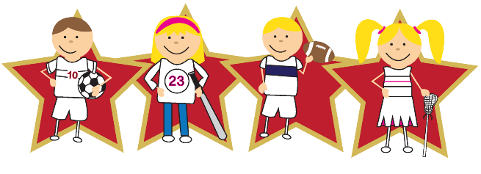

**Healthy living**

We learn about how our actions and behaviours impact our lives and health. We investigate and sample new and healthy food such as fruits and veg.

We take part in cooking lessons with seasonal produce to help us understand where our food comes from.

We discuss safety and think about ways to keep ourselves safe when we are out and about, eg, crossing the road, cycling helmets.

We also discuss wider health issues such as oral health and good sleep routines.

**Key Vocabulary** **Locomation Object control Stability Gymnastics Sports Gross motor Oral health Fruit Healthy Unhealthy Moderation**

