

**Set 1**

In set 1 we learn all the letters of the alphabet and the first 6 digraphs. We use these sounds to blend together CVC words. Red words are taught. They can not be sounded out as they do not match the phonetical code.

EG c-a-t = cat or th-i-in = thin

Red words: the, I, put, go, my, of, no, me,

**Literacy – Phonics (RWI)**

Phonics is a way of learning to read by understanding the sounds that letters make and how they work together to make words. There are 26 letters in the alphabet: **ABCDEFGHIJKLMNOPQRSTUVWXYZ.** Letters are split into vowels (AEIOU) and consonants (all the other letters).

**Overview**

At St Catherine’s we follow the RWI phonics programme. More information can be found <https://www.ruthmiskin.com/programmes/phonics/about-read-write-inc-phonics/>

We learn that letter shapes make sounds and that these sounds work together to make words. We use ‘Fred talk’ to help us segment and blend sounds to read words.

In the EYFS, early reading knowledge is based within **‘Literacy’,** and ‘**Communication and language’** learning areas.

St Catherine’s School – Foundation 2 – Knowledge Overview – Reading

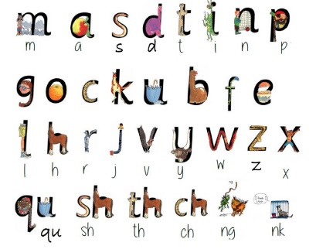

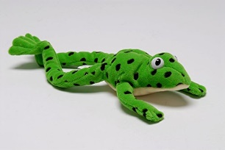

**Communication and Language**

**Vocabulary**

Vocabulary means the words we know and use. We explicitly teach through high quality and diverse texts to expose children to new and challenging vocabulary. We aim to build on vocabulary each term.

**Questioning**

We question children to gather understanding of what children have heard. Questions can be open (how and why?) or closed (who, where and what)

**Books**

Children learn that books have pages and are made of words and pictures. Books are read from left to right and top to bottom. There are a variety of books from poetry to comics and non fiction.

**Set 2**

By the end of Foundation we should reach the end of set 2. Set 2 is made up of many digraphs and tricky words.

Red words: your, said, he, are, you, she, be, ask, says, our, go, want, was, into

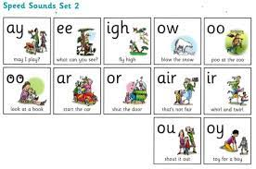



**Key Vocabulary** **Books Sounds Letters Sentences Vowel Consonant Digraph Blending Phonics**