
St. Catherine’s C of E Primary School
Launceston
Cornwall
PL15 7HX


Executive Headteacher: Mrs Louise Hussey Telephone: 01566 772198
Email: stcatherines@andaras.org WEBSITE – www.stcatherinescofe.co.uk

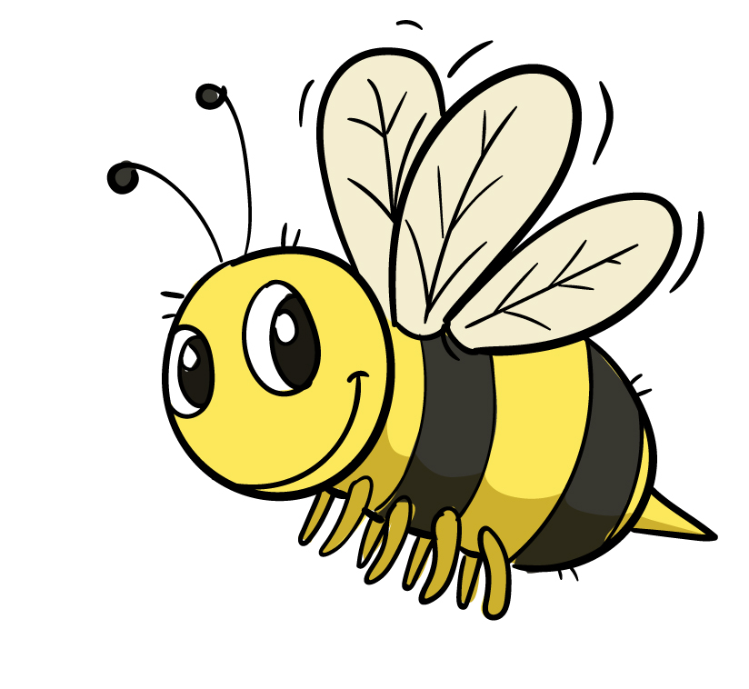
23.5.22
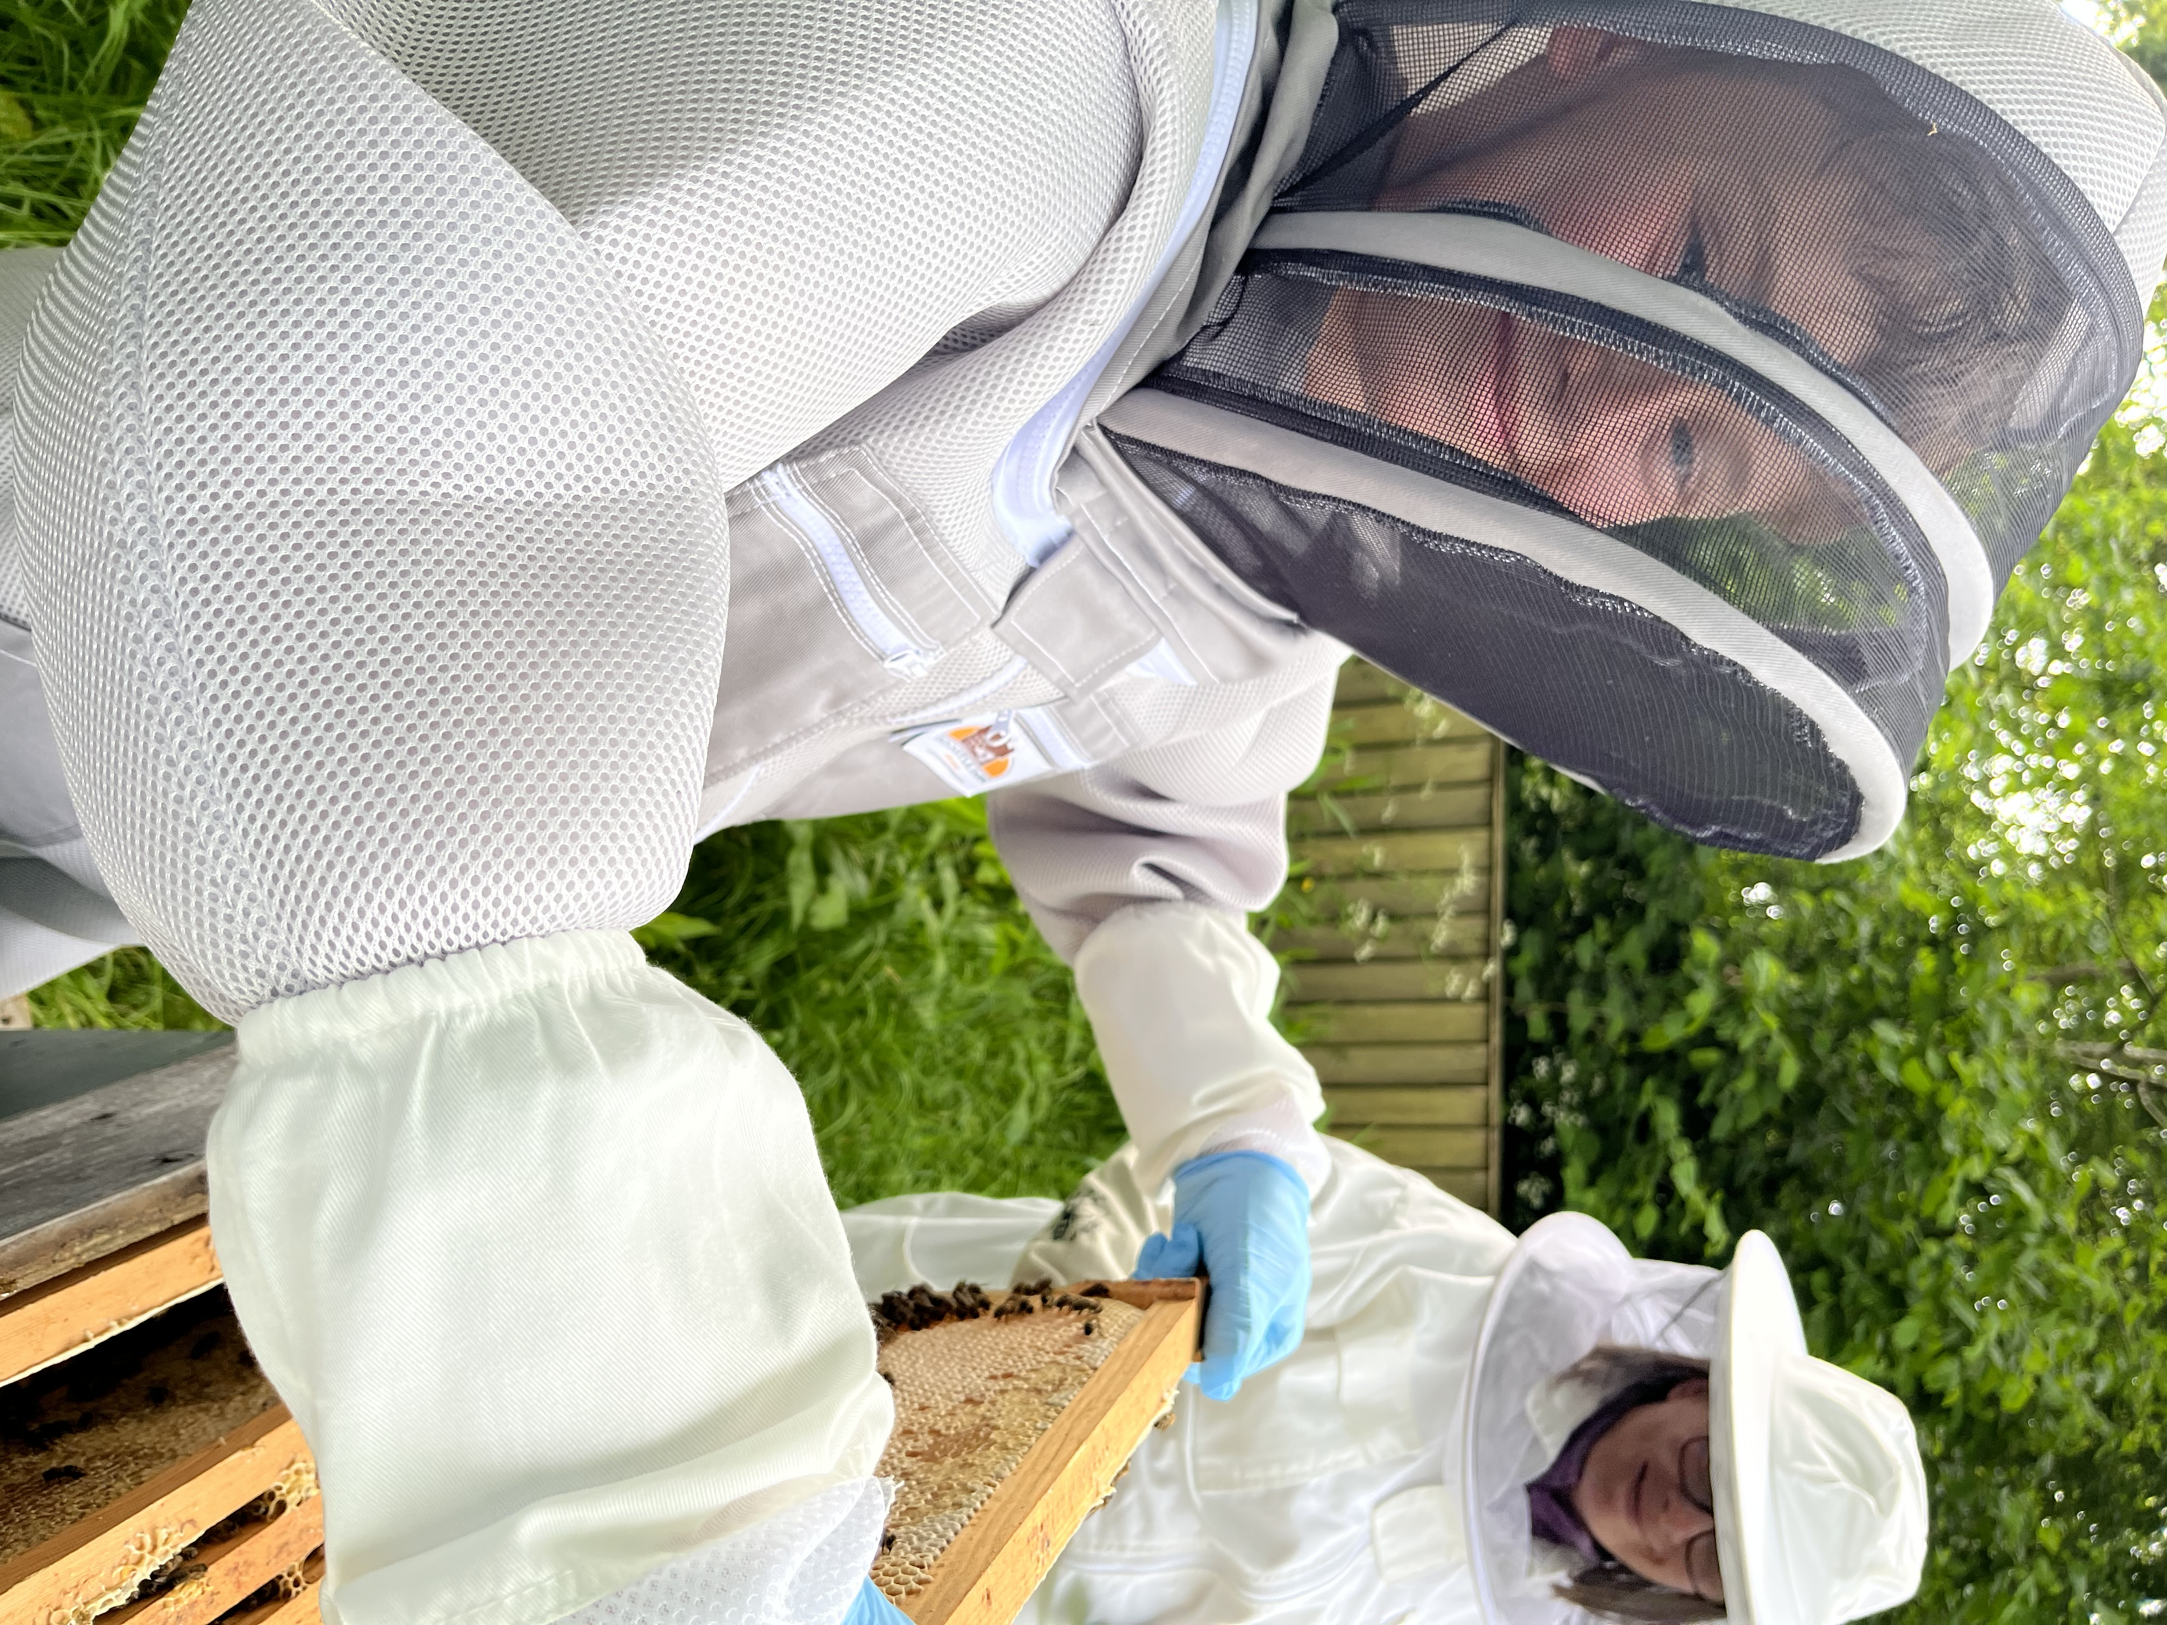
Dear Parents,
Our bees have settled in well to their new homes and are ready to start having visits. Your child has expressed an interest in visiting and meeting our bees.
Mrs Parish and Mrs Bishop will be taking pairs of children in to watch as they maintain the bees over the next half term.
Viewing slots will be on Tuesdays after school. The school has children’s bees suits and a clear set of guidelines for the children to follow as they view the bees.
If you are happy for your child to do this, please complete the form below. Your child will then be allocated a slot for one of the after-school sessions between now and the end of the summer term.
In September, those interested in more work with the bees will have the chance to join ‘Bee club’.
It is important to know that bee viewing is weather dependent and the slot may be cancelled at short notice. In these cases, a new slot will be allocated at a later date.
Many thanks
Louise Hussey
Headteacher
………………………………………………………………………………………………………..
I give permission for my child ………………………………..to enter the Bee Apiary wearing a protective bee suit to view the bees.
And I give permission for the school to administer Piriton to my child if they are stung by a bee.
Signed……………………………………………………. Date………………………………

