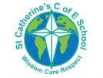

**Singing**

Singing is when we use our voice to make music.

Children will learn to control their voice and experiment with pitch and tone. Singing takes place in small groups, whole school worship and solo opportunities during play.

**Overview**

At St Catherine’s in expressive arts and design we cover aspects of music. We learn about to be creative with sounds, to listen and perform music and songs.

In the EYFS, early musical knowledge is based within ‘**Communication and language’**, **‘personal, social and emotional development**  and **‘Expressive arts and design’** learning areas.

St Catherine’s School – Foundation 2 – Knowledge Overview – Music (EAD)

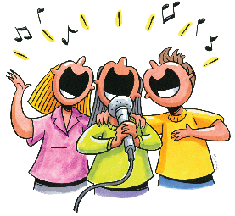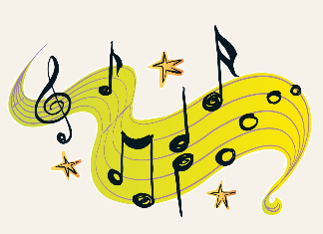

**Dancing and Moving**

Dancing and moving is when we learn to move our body in time to music.

We will learn how to do this through specific PE lessons as well as being allowed to create dances during continuous provision and watching others perform.

**Being imaginative**

Using your imagination is about creating your own new things. Children are encouraged to create their own music using a range of instruments;

* Drums, xylophone, triangles, keyboards, percussion.

**Key Vocabulary music beat voice instrument singing dancing evaluate express pitch tone solo group**



