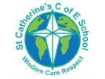

**Materials**

Children use a range of materials to create pictures and models. Children are taught how to use different products and are allowed to practice to find the medium that they prefer.

Materials include:

* Paintbrushes
* Sellotape
* Masking tape
* PVA glue
* Prit-stick
* Tissue paper
* Wax crayons
* Oil pastels
* Felt tips
* Clay
* Natural materials.

**Overview**

At St Catherine’s in expressive arts and design we cover aspects of Art and Design Technology. We learn about to express our feelings using colour and different mediums. We also learn how to construct and work as a team to complete a project.

In the EYFS, early art knowledge is based within ‘**Communication and language’**, **‘personal, social and emotional development, physical development** and **‘Expressive arts and design’** learning areas.

St Catherine’s School – Foundation 2 – Knowledge Overview – Art and DT (EAD)

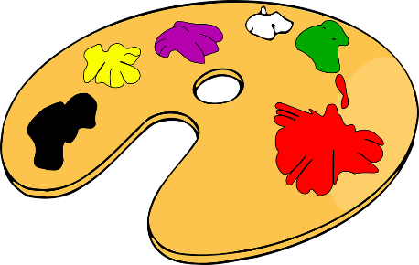

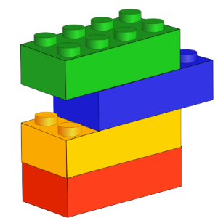

**Being imaginative**

Using your imagination is about creating your own new things. Children are encouraged to create their own models and designs through construction activities. Children are encouraged to work together to complete large tasks.

**Key Vocabulary colour shape texture pattern gallery museum artist reflect collaborate join**

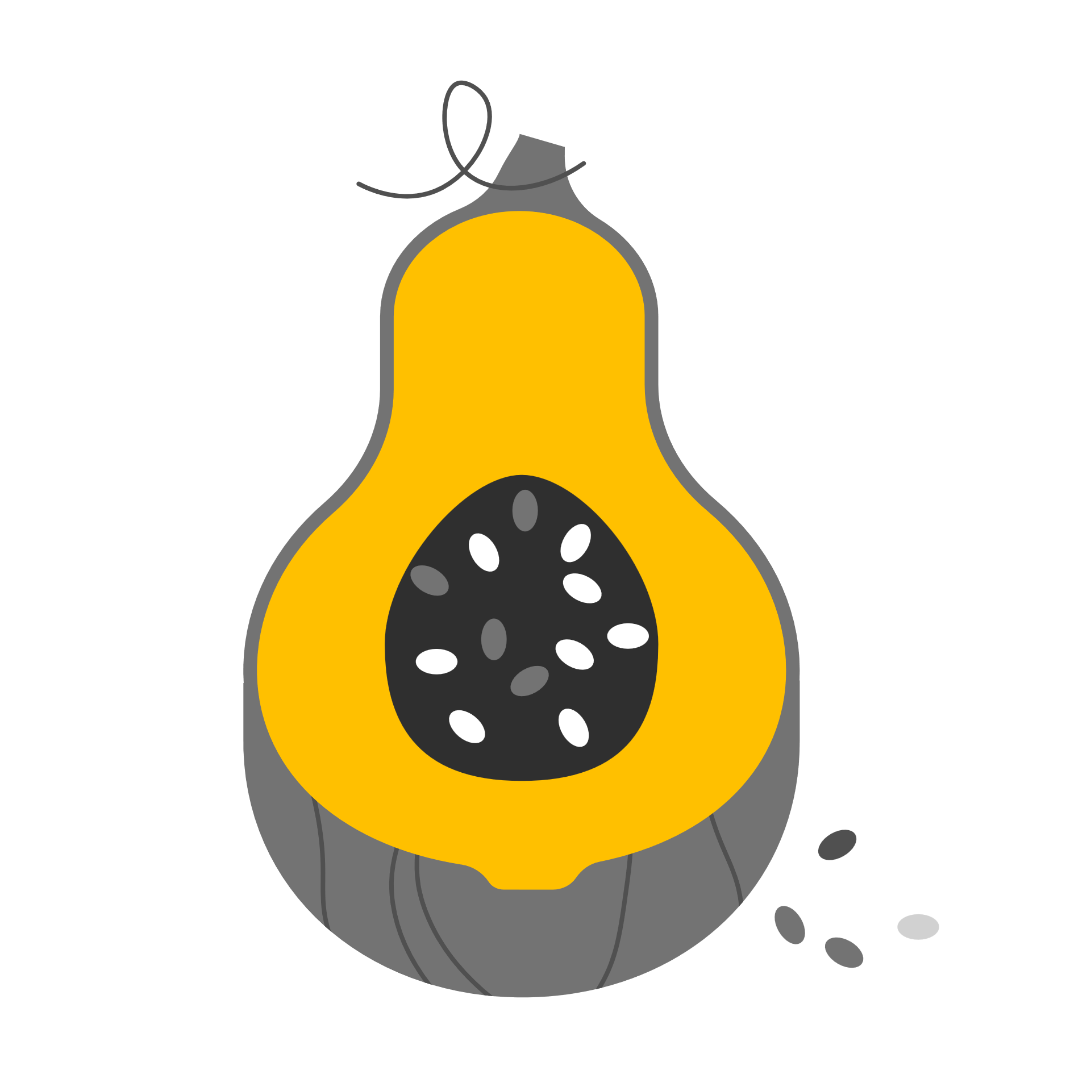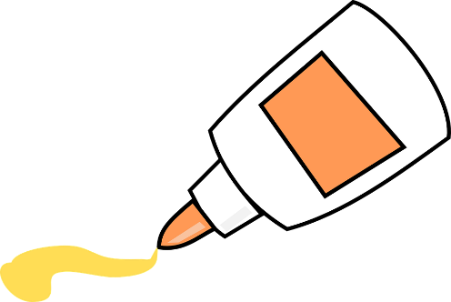

Children will explore different types of foods and textures by creating with food. Children will be able to cut and cook different fruits and vegetables, eventually trying their recipes.

