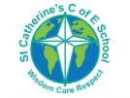

**Handwriting**

In FS2 we use print as a handwriting style. We use LetterJoin to guide the teaching of handwriting.

Letters are split into 3 groups:

**Small letters**: a e i o w u n m c v s x z r

**Tall letters** (ascenders): t d h k l b

**Long letters** (descenders): q y p f g j

**Literacy – Phonics (RWI)**

Phonics is a way of learning to read by understanding the sounds that letters make and how they work together to make words. By the end of the EYFS children should be able to form letters accurately and write short sentences that can be read by others. These sentences include a mix of correctly spelt words, phonetically spelt words and red words.

**Overview**

At St Catherine’s we follow the RWI phonics programme. We use “Drawing club” as a template to support independent writing. LetterJoin is used to help us formulate a fluent handwriting style.

Writing skills are built on strong speaking, listening and reading skills. As these skills develop, children move from mark making to forming letters and words.

In the EYFS, early writing knowledge is based within **‘Literacy’,** ‘**Communication and language’** and ‘**Physical Development’** learning areas.

St Catherine’s School – Foundation 2 – Knowledge Overview – Writing

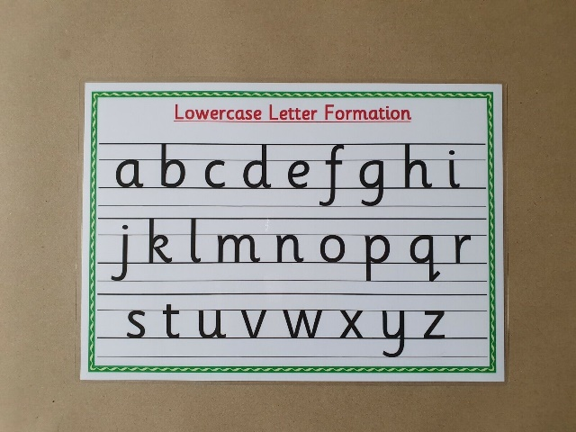

**Physical Development**

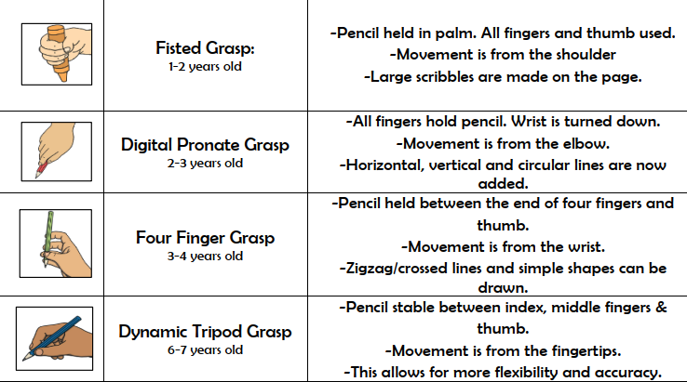

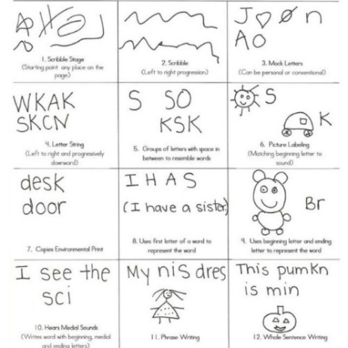

**Writing Development**

In Foundation children will move through many stages in writing development. Children will be able to:

Draw pictures with increased detail. Label pictures using familiar CVC words (mum, dad, cat, dog). Spell with phonetical accuracy. Write short sentences or cations that can be read by others.

**Key Vocabulary** **Pencil Sounds Letters Sentences Vowel Consonant Digraph Blending Punctuation**