

Using the school’s programme I Compute as a guide children will have opportunities throughout the year to:

* Sequence patterns
* Use a key board
* Use a mouse
* Sort objects on a screen
* Create a picture using a programme
* Control a robot
* Direct a robot
* Design safety posters

**Overview**

At St Catherine’s computing is taught through expressive arts and design. Although no longer statutory in the EYFS framework the importance of computing is clear in the 21st century and the children are taught foundational skills to understand technology and the vocabulary around this subject area.

In the EYFS, early computing knowledge is based within ‘**Communication and language’**, **‘personal, social and emotional development, physical development** and **‘Expressive arts and design’** learning areas.

St Catherine’s School – Foundation 2 – Knowledge Overview – Computing (EAD)

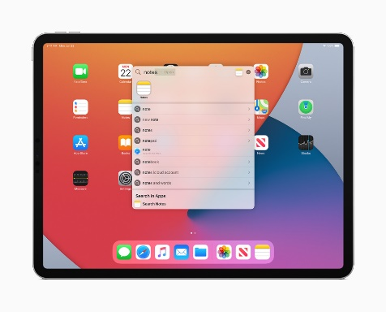

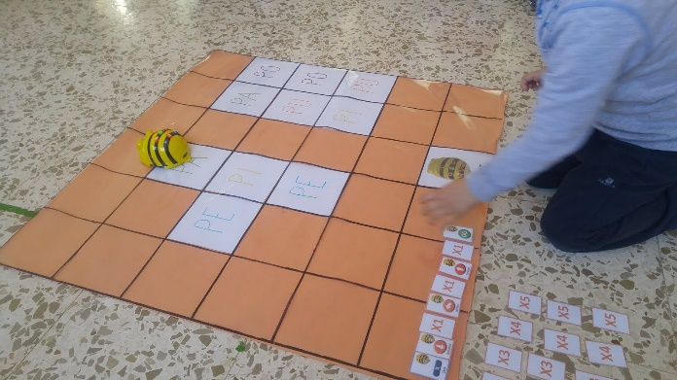

**Computer safety**

Children will learn how to remain safe when accessing technology and what to do if they feel worried or unsafe when on a device.

Internet safety day is celebrated, and parents are supported to understand PEGI rating on games and films.



**Key Vocabulary sort sequence pattern safety control direct user password type**

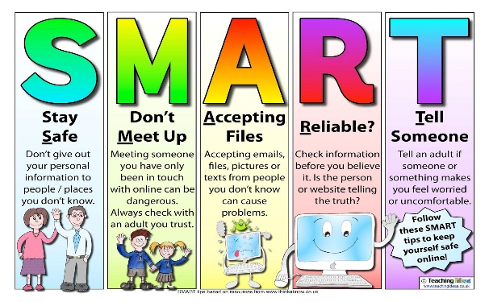

[This Photo](https://evaggeliasariggoli.blogspot.com/2019/02/safer-internet-day.html) by Unknown Author is licensed under [CC BY-NC-ND](https://creativecommons.org/licenses/by-nc-nd/3.0/)

Children are given the opportunity to explore a variety of technology from desktop computers with a mouse, touch screen devices and will explore technology and how it has changed from the past to now.