|  |  |
| --- | --- |
| **Understanding the world** | |
| **The Earth** | We learn about how our planet was created (religious and scientific). Explore the solar system in which the Earth sits. On Earth look at locations including how our own local area has changed over time. |
| **The seasons** | We learn there are 12 months in a year and learn their names. We investigate the changes to the weather over the course of the year and learn the 4 seasons. |
| **Environments** | Environments are the surroundings. We look into a variety of environments through picture books. Mountain, river, sea, coast, city |
| **Plants** | We learn that plants are living things and we investigate what they need to grow. We take part in woodland school learning to help look after our school plants. |
| **Animals** | We learn about a variety of animals. We learn about where they live (habitat) and what they eat. We discuss domestic and wild animals as well as endangered and extinct. |
| **Natural vs Man made** | We learn about the Earth and how it looked before Humans, in particular mountains, rivers and deserts. We discuss inventions that humans have contributed and compare and contrast items such as homes. |

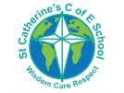

**Overview**

At St Catherine’s in understanding the world we cover aspects of science. We look and explore the world around us.

We ask questions and conduct experiments to see if we can understand how and why something happens.

In the EYFS, early science knowledge is based within ‘**Communication and language’**, **Understanding the world’** and ‘**Physical Development’** learning areas.

St Catherine’s School – Foundation 2 – Knowledge Overview – Science (UTW)

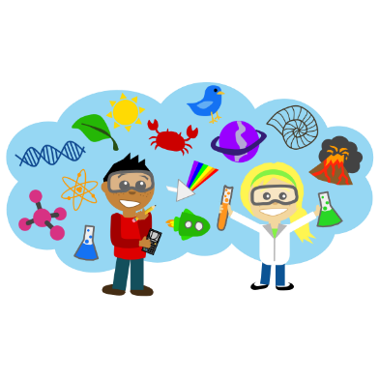

**Physical Development link**

During our science learning we improve our physical development skills by using small tools to help us conduct our research. Such as:

* Pencil, ruler, measuring jug, spade, tape, magnifying glass, tweezers.

We also learn about how to keep the human, from the 5 senses to keeping our bodies healthy. This is done through:

* Learning about fruit and veg, trying new foods, drinking lots of water, learning about oral hygiene and taking part in a PE lesson every week.

**Key Vocabulary** **Experiment Observe Earth Space Living things Habitat Healthy Planet Scientist**

