|  |  |
| --- | --- |
| **Understanding the world** | |
| **The Earth** | We learn about how our planet was created (religious and scientific). Explore the solar system in which the Earth sits. On Earth look at locations including how our own local area has changed over time. |
| **Family and Friends** | We learn that families are all different. We discuss what you know about your own family.  We learn that we share qualities with our friends but some things we have a different and make us unique. |
| **Experiences** | We investigate life experiences by looking at large events such as:  weddings, christenings, birthdays, starting school, birth of a brother or sister. |
| **Occupations** | We learn about a variety of occupations and why they are important. We look at the choices of occupations in the past and what you aspire to be when you are older. |
| **Animals** | We learn about a variety of animals. We learn about where they live (habitat) and what they eat. We discuss domestic and wild animals as well as endangered and extinct. |
| **Natural vs Man made** | We learn about the Earth and how it looked before Humans, in particular mountains, rivers and deserts. We discuss inventions that humans have contributed and compare and contrast items such as homes. |

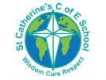

**Overview**

At St Catherine’s in understanding the world we cover aspects of History. We learn about things that have happened in the past.

By learning about the past we can try and understand why we have things in the present. Finally we can look forward to the future and discuss what might happen next.

By learning about our local area, families and friends we can learn the early skills of history.

In the EYFS, early History knowledge is based within ‘**Communication and language’**, and **Understanding the world’** learning areas.

St Catherine’s School – Foundation 2 – Knowledge Overview – History (UTW)

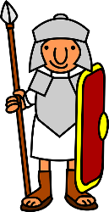

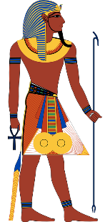

**Changes over time**

We learn that everything changes over time. We learn this through historical documents (such as the old headmaster diaries), photographs and maps of the local area. We invite older members of our community to visit and discuss their memories with us.

We also look at how humans and animals change over time, looking at birth, growth and decay.

**Key Vocabulary** **History Past Present Future Time Family Life cycle Earth Community Occupation**

