Ordering School Dinners on School Money
As a school and in support of us being ‘cashless’, we use the School Money system to order dinners.
You will be required to order all school dinners via School Money. This will be including Universal Free School Meals (Rec, Y1 and Y2), Free School Meals (if eligible) and paid for dinners. EVERYONE MUST ORDER ONLINE.
This system will enable you to choose the meals for your child for the week, and to then pay by card if payment is required.
The menu will remain the same as the paper Chartwells ones sent home with a Main or Vegetarian option every day , so please keep these to refer to, but they will not be described fully on the School Money system. For example:
The first column ‘Cheese & Tomato Pizza with Potato Wedges’ would be written as ‘MAIN’, then the second column is the vegetarian option for that day ‘Chinese Veggie Noodles’ would be written as ‘VEG’. Both dinners have the same options for Sides and Desserts: Sweetcorn & Broccoli on the side and Mango Frozen Yoghurt for dessert’
There will also still be the option for Hoagies each day (Ham, Cheese or Tuna Mayo), a Jacket Potato (fillings chosen by the child on the day) or Tomato Pasta.
How to Book
Go to School Money website, log into your account, you will then be able to make bookings for your child.
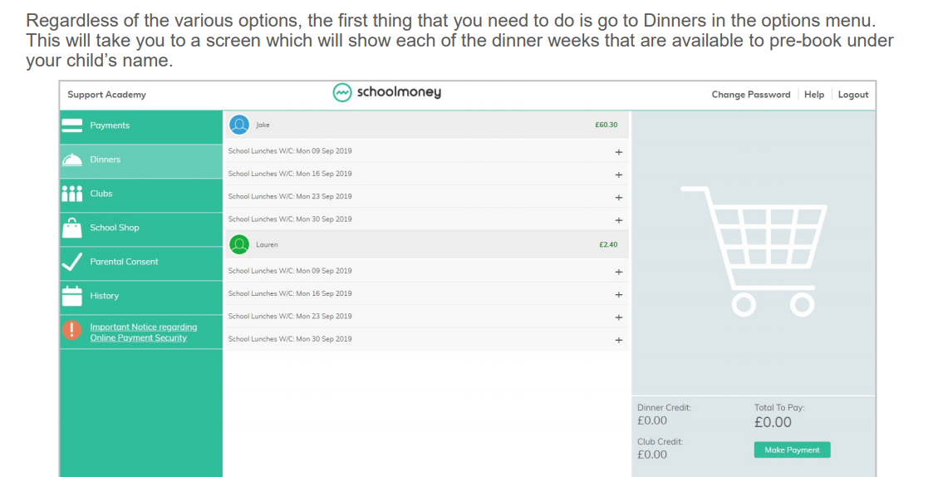
Chartwells will be continuing their offer of 5 meals for the price of 4, if you have selected meals for every day of the week then please select the 5/4 option on the Friday which is free of charge. If this is selected incorrectly without ordering for every day of the week it will be amended in the office and set for payment upon next log in.
If there is a ‘Special Menu’ Day, for example 5th November Bonfire Night, you will receive advanced notice of the menu change and will still order as normal choosing MAIN or VEG etc.
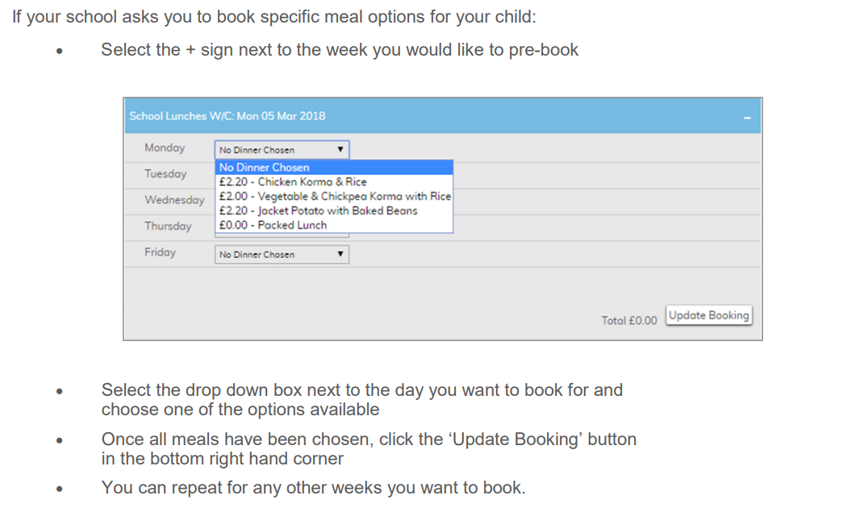
If your child is in receipt of Free School Meals or in Rec, Y1 and Y2 so receives Universal Free School Meals, you still need to go onto the system before the start of each week to order their meals.
You would then make your choices, select ‘Update Booking’ and this will save your choices, without generating any bill to pay.
For paid dinners, once you have completed your bookings and ‘Update Booking’, you can go to the make payment screen.
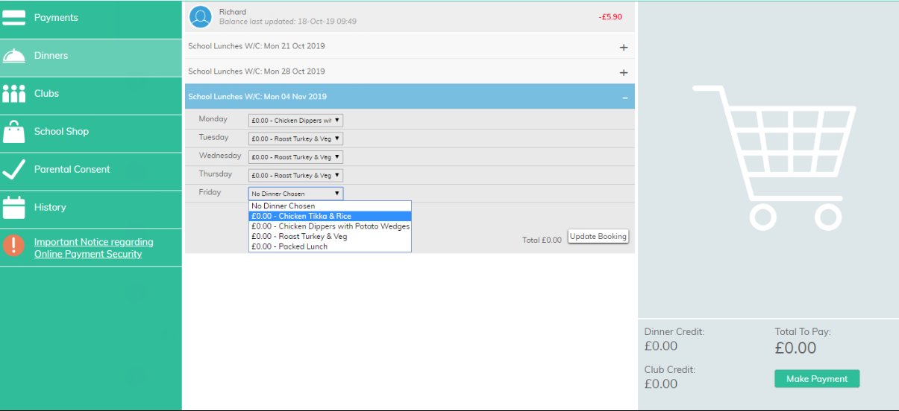
We will still be requiring orders to be made at the start of each week for the whole week, however these must ALL be keyed on the system before midnight on the Sunday before the start of that week. Orders will not be able to be taken by classroom teachers. Please speak to the office if you have any issues logging in.

